The following is a short extract about the enneagram from Ouspensky’s “In Search of the Miraculous” pp 285-295.

"We have spoken earlier of the law of octaves, of the fact that every process, no matter upon what scale it takes place, is completely determined in its gradual development by the law of the structure of the seven-tone scale. In connection with this it has been pointed out that every note, every tone, if taken on another scale is again a whole octave. The 'intervals' between mi and fa and between si and do which cannot be filled by the intensity of the energy of the process in operation, and which require an outside 'shock,' outside help so to speak, connect by this very fact one process with other processes. From this it follows that the law of octaves connects all processes of the universe and, to one who knows the scales of the passage and the laws of the structure of the octave, it presents the possibility of an exact cognition of everything and every phenomenon in its essential nature and of all its interrelations with phenomena and things connected with it.
"For uniting into one whole all knowledge connected with the law of the structure of the octave there is a certain symbol which takes the form of a circle divided into nine parts with lines connecting the nine points on the circumference in a certain order.
"Before passing on to the study of the symbol itself it is essential to understand certain aspects of the teaching which makes use of this symbol, as well as the relation of this teaching to other systems which make use of symbolical methods for the transmission of knowledge.
"In order to understand the interrelation of these teachings it must always be remembered that the ways which lead to the cognition of unity approach it like the radii of a circle moving towards the center; the closer they come to the center, the closer they approach one another.
"As a result of this the theoretical statements which form the basis of one line can sometimes be explained from the point of view of statements of another line and vice versa. For this reason it is sometimes possible to form a certain intermediate line between two adjacent lines. But in the absence of a complete knowledge and understanding of the fundamental lines, such intermediate ways may easily lead to a mixing of lines, to confusion and error.
"Of the principal lines, more or less known, four can be named:
The Hebraic
The Egyptian
The Persian
The Hindu
"Moreover of the last we know only its philosophy, and of the first three, parts of their theory.
"In addition to these there are two lines known in Europe, namely theosophy and so-called Western occultism, which have resulted from a mixture of the fundamental lines. Both lines bear in themselves grains of truth, but neither of them possesses full knowledge and therefore attempts to bring them to practical realization give only negative results.
"The teaching whose theory is here being set out is completely self-supporting and independent of other lines and it has been completely unknown up to the present time. Like other lines it makes use of the symbolical method and one of its principal symbols is the figure which has been mentioned, that is, the circle divided into nine parts:
"This symbol takes the following form:
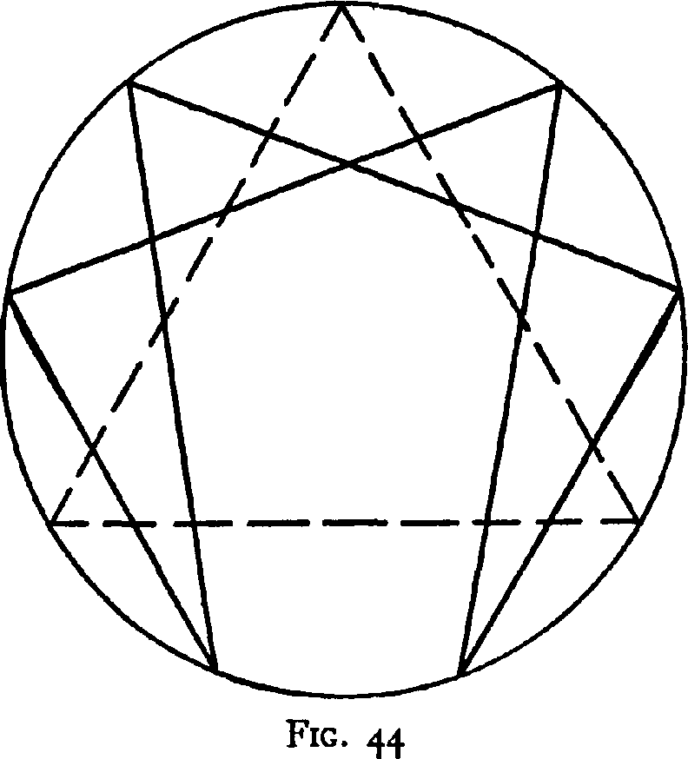
"The circle is divided into nine equal parts. Six points are connected by a figure which is symmetrical in relation to a diameter passing through the uppermost point of the divisions of the circumference. Further, the uppermost point of the divisions is the apex of an equilateral triangle linking together the points of the divisions which do not enter into the construction of the original complicated figure.
"This symbol cannot be met with anywhere in the study of 'occultism,' either in books or in oral transmission. It was given such significance by those who knew, that they considered it necessary to keep the knowledge of it secret.
"Only some hints and partial representations of it can be met with in literature. Thus it is possible to meet with a drawing of it like this:
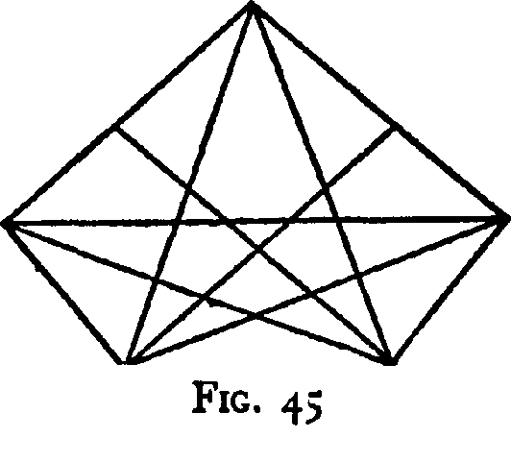
"And another like this:
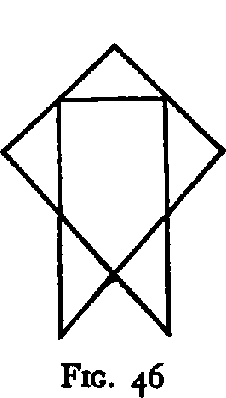
"The symbol which takes the form of a circle divided into nine parts with lines connecting them together expresses the law of seven in its union with the law of three.
"The octave possesses seven tones and the eighth is a repetition of the first Together with the two 'additional shocks' which fill the 'intervals' mi-fa and si-do, there are nine elements.
"The complete construction of this symbol which connects it with a complete expression of the law of octaves is more complicated than the construction shown. But even this construction shows the inner laws of one octave and it points out a method of cognizing the essential nature of a thing examined in itself.
"The isolated existence of a thing or phenomenon under examination is the closed circle of an eternally returning and uninterruptedly flowing process. The circle symbolizes this process. The separate points in the division of the circumference symbolize the steps of the process. The symbol as a whole is do, that is, something with an orderly and complete existence. It is a circle—a completed cycle. It is the zero of our decimal system; in its inscription it represents a closed cycle. It contains within itself everything necessary for its own existence. It is isolated from its surroundings. The succession of stages in the process must be connected with the succession of the remaining numbers from 1 to 9. The presence of the ninth step filling up the 'interval' si-do, completes the cycle, that is, it closes the circle, which begins anew at this point. The apex of the triangle closes the duality of its base, making possible the manifold forms of its manifestation in the most diverse triangles, in the same way as the point of the apex of the triangle multiplies itself infinitely in the line of its base. Therefore every beginning and completion of the cycle is situated in the apex of the triangle, in the point where the beginning and the end merge, where the circle is closed, and which sounds in the endlessly flowing cycle as the two do's in the octave. But it is the ninth step that closes and again begins a cycle. Therefore in the upper point of the triangle corresponding to do stands the number 9, and among the remaining points are disposed the numbers 1 to 8.
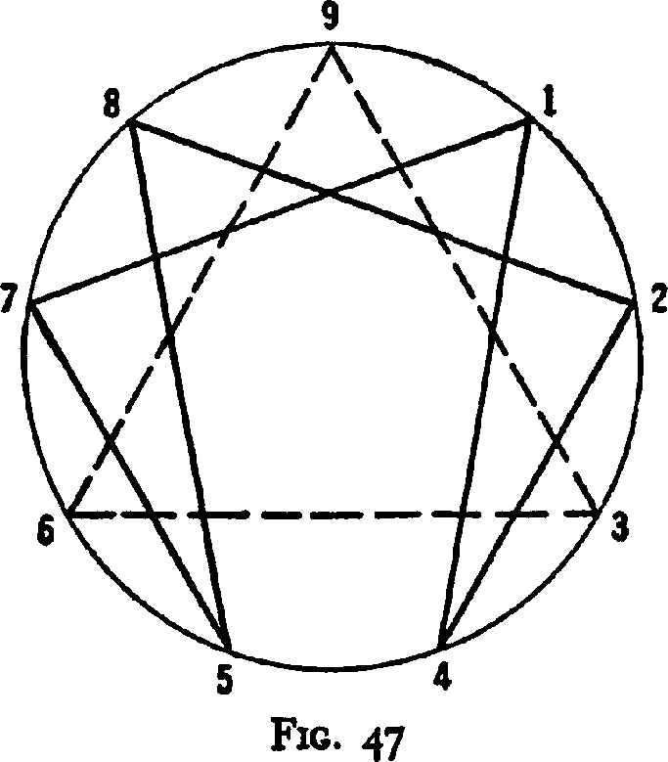
"Passing on to the examination of the complicated figure inside the circle we should understand the laws of its construction. The laws of unity are reflected in all phenomena. The decimal system is constructed on the basis of the same laws. Taking a unit as one note containing within itself a whole octave we must divide this unit into seven unequal parts in order to arrive at the seven notes of this octave. But in the graphic representation the inequality of the parts is not taken into account and for the construction of the diagram there is taken first a seventh part, then two-sevenths, then three-sevenths, four-sevenths, five-sevenths, six-sevenths, and seven-sevenths. Calculating these parts in decimals we get:
1/7—0.142857...
2/7—0.285714...
3/7—0.428571...
4/7—0.571428...
5/7—0.714285...
6/7—0.857142...
7/7—0.999999...
"In examining the series of periodic decimals obtained we at once see that in all except the last the periods consist of exactly the same six digits which run in a definite sequence, so that, knowing the first digit of the period, it is possible to reconstruct the whole period in full.
"If we now place on the circumference all the nine numbers from 1 to 9 and connect those numbers which are included in the period by straight lines in the same sequence in which the numbers stand in the period, according to which number we start from, we shall obtain the figure found inside the circle. The numbers 3, 6, and 9 are not included in the period. They form the separate triangle—the free trinity of the symbol.
"Making use of 'theosophical addition' and taking the sum of the numbers of the period, we obtain nine, that is, a whole octave. Again in each separate note there will be included a whole octave subject to the same laws as the first. The positions of the notes will correspond to the numbers of the period and the drawing of an octave will look like the following:
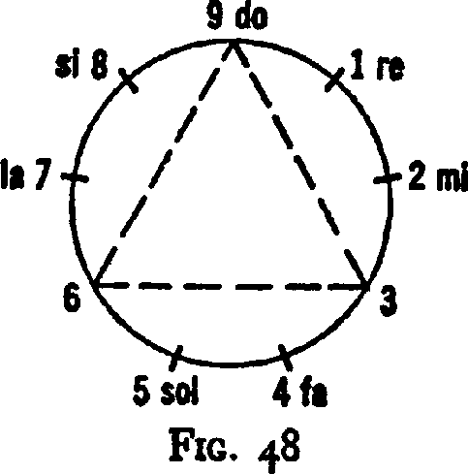
"The triangle 9-3-6, which unites into one whole the three points on the circumference not included in the period, connects together the law of seven and the law of three. The numbers 3-6-9 are not included in the period; two of them, 3 and 6, correspond to the two 'intervals' in the octave, the third is, so to speak, superfluous and at the same time it replaces the fundamental note which does not enter the period. Moreover, any phenomenon which is able to act reciprocally with a phenomenon similar to it sounds as the note do in a corresponding octave. Therefore do can emerge from its circle and enter into orderly correlation with another circle, that is, play that role in another cycle which, in the cycle under consideration, is played by the 'shocks' filling the 'intervals' in the octave. Therefore, here also, by having this possibility do is connected by the triangle 3-6-9 with those places in the octave where the shocks from outside sources occur, where the octave can be penetrated to make connection with what exists outside it. The law of three stands out, so to speak, from the law of seven, the triangle penetrates through the period and these two figures in combination give the inner structure of the octave and its notes.
"At this point in our reasoning it would be entirely right to raise the question: Why is one of the 'intervals' which is designated by the number 3 found in its right place between the notes mi and fa, and the other, which is designated by the number 6, found between sol and la, when its right place is between si and do.
"If the conditions had been observed as to the appearance of the second interval (6) in its own place, we should have had the following circle:
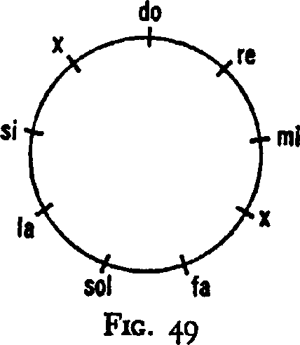
And the nine elements of the closed cycle would have been grouped symmetrically together in the following way:
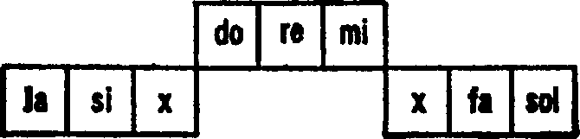
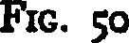
"The distribution we do get:
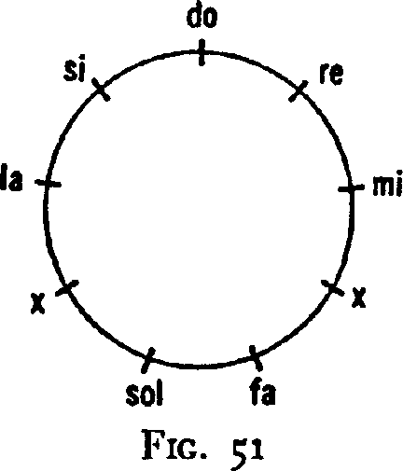
can only give the following grouping:
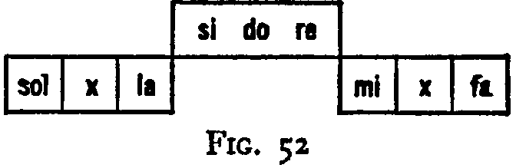
that is, in one case x between mi and fa, and in the other between sol and la, where it is not necessary.
"The apparent placing of the interval in its wrong place itself shows to those who are able to read the symbol what kind of 'shock' is required for the passage of si to do.
"In order to understand this, it is essential to recollect what was said about the role of 'shocks' in the processes proceeding in man and in the universe.
"When we examined the application of the law of octaves to the cosmos then the step 'sun-earth' was represented in this way:
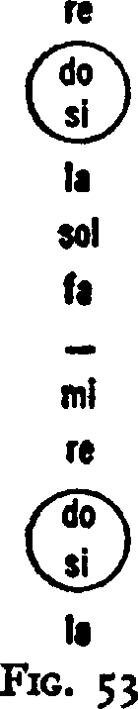
"In relation to the three octaves of radiation it was pointed out that the passage of do to si, the filling of the interval, takes place within the organism of the sun. It was pointed out in the cosmic octave in relation to the 'interval' do-si that this passage is accomplished by the will of the Absolute. The passage fa-mi in the cosmic octave is accomplished mechanically with the help of a special machine which makes it possible for fa, which enters it, to acquire by a series of inner processes the characteristics of sol standing above it, without changing its note, that is, to accumulate, as it were, the inner energy for passing independently into the next note, into mi.
"Exactly the same relationship is repeated in all completed processes. In examining the processes of nutrition in the human organism and the transformation of the substances taken into the organism, we find in these processes exactly the same 'intervals' and 'shocks.'
"As we pointed out before, man takes in three kinds of food. Each one of them is the beginning of a new octave. The second octave, that is, the air octave, joins up with the first, that is, the octave of food and drink, at the point where the first octave comes to a stop in its development at the note mi. And the third octave joins up with the second at the point where the second octave comes to a stop in its development at the note mi.
"But it must be understood that, just as in many chemical processes, only definite quantities of substances, exactly determined by nature, give compounds of the required quality, so in the human organism the 'three kinds of food' must be mixed in definite proportions.
"The final substance in the process of the food octave is the substance si ('hydrogen' 12 in the third scale), which needs an 'additional shock' in order to pass into a new do. But as three octaves have taken part in the production of this substance their influence is also reflected in the final result by determining its quality. The quality and quantity can be regulated by regulating the three kinds of food received by the organism. Only in the presence of a full and harmonious conformity between all three kinds of food, by a strengthening or weakening of the different parts of the process, is the required result obtained.
"But it is essential to remember that no arbitrary attempts to regulate food, in the literal sense of the word, or breathing can lead to the desired end unless one knows exactly what one is doing and why, and what kind of result it will give.
"And furthermore, even if a man were to succeed in regulating two components of the process, food and breathing, again this would not be enough, because it is still more important to know how to regulate the food of the third story—'impressions.'
"Therefore before even thinking of influencing practically the inner processes it is essential to understand the exact mutual relationship of the substances entering the organism, the nature of the possible 'shocks,' and the laws governing the transition of notes. These laws are everywhere the same. In studying man we study the cosmos, in studying the cosmos we study man.
"The cosmic octave 'Absolute-moon' has, according to the law of three, been broken into three subordinate octaves. In these three octaves the cosmos is like man; the same 'three stories,' the same three shocks.
"Where, in the cosmic octaves of radiation, the place of the interval fami appears, in the diagram are marked the 'machines' which are found there in the same way as in the human body.
"The process of the transition fa-mi can be represented in the most schematic way thus: the cosmic fa enters this machine like the food of the lower story and begins its cycle of changes. Therefore in the beginning it sounds in the machine as do. The substance sol of the cosmic octave serves as the substance which enters the middle story like the air in breathing, which helps the note fa inside the machine to pass into the note mi. This sol on entering the machine also sounds as do. The matter which has now been obtained is joined in the upper story by the substance of the cosmic la, which enters the upper story of the machine, also as do.
"As we see from this the following notes la, sol, fa serve as food for the machine. In the order of their succession, according to the law of three, la will be the active element, sol the neutralizing, and fa the passive. The active principle reacting with the passive (that is, becoming connected with it by the help of the neutralizing principle) gives a certain definite result. This is represented symbolically thus:
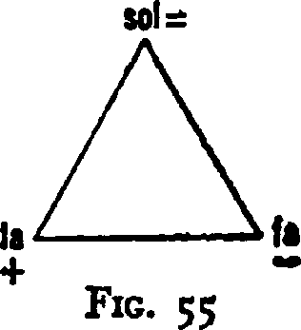
"This symbol points out that the substance fa in being mixed with the substance la gives as a result the substance sol. And as this process proceeds in the octave, developing as it were inside the note fa, it is therefore possible to say that fa without changing its pitch acquires the properties of sol.
"All that has been said about the octaves of radiation and about the food octaves in the human organism has a direct connection with the symbol consisting of a circle divided into nine parts. This symbol, as the expression of a perfect synthesis, contains within itself all the elements of the laws it represents, and from it can be extracted, and by its help transmitted, everything that is connected with these octaves and much else besides."
G. returned to the enneagram many times and in various connections. "Each completed whole, each cosmos, each organism, each plant, is an enneagram," he said. "But not each of these enneagrams has an inner triangle. The inner triangle stands for the presence of higher elements, according to the scale of 'hydrogens,' in a given organism. This inner triangle is possessed by such plants, for example, as hemp, poppy, hops, tea, coffee, tobacco, and many other plants which play a definite role in the life of man. The study of these plants can reveal much for us in regard to the enneagram.
294
"Speaking in general it must be understood that the enneagram is a universal symbol. All knowledge can be included in the enneagram and with the help of the enneagram it can be interpreted. And in this connection only what a man is able to put into the enneagram does he actually know, that is, understand. What he cannot put into the
enneagram he does not understand. For the man who is able to make use of it, the enneagram makes books and libraries entirely unnecessary. Everything can be included and read in the enneagram. A man may be quite alone in the desert and he can trace the enneagram in the sand and in it read the eternal laws of the universe. And every time he can learn something new, something he did not know before.
"If two men who have been in different schools meet, they will draw the enneagram and with its help they will be able at once to establish which of them knows more and which, consequently, stands upon which step, that is to say, which is the elder, which is the teacher and which the pupil. The enneagram is the fundamental hieroglyph of a universal language which has as many different meanings as there are levels of men.
"The enneagram is perpetual motion, the same perpetual motion that men have sought since the remotest antiquity and could never find. And it is clear why they could not find perpetual motion. They sought outside themselves that which was within them; and they attempted to construct perpetual motion as a machine is constructed, whereas real perpetual motion is a part of another perpetual motion and cannot be created apart from it. The enneagram is a schematic diagram of perpetual motion, that is, of a machine of eternal movement. But of course it is necessary to know how to read this diagram. The understanding of this symbol and the ability to make use of it give man very great power. It is perpetual motion and it is also the philosopher's stone of the alchemists.
"The knowledge of the enneagram has for a very long time been preserved in secret and if it now is, so to speak, made available to all, it is only in an incomplete and theoretical form of which nobody could make any practical use without instruction from a man who knows.
"In order to understand the enneagram it must be thought of as in motion, as moving. A motionless enneagram is a dead symbol; the living symbol is in motion."
Much later—it was in the year 1922—when G. organized his Institute in France and when his pupils were studying dances and dervish exercises, G. showed them exercises connected with the "movement of the enneagram." On the floor of the hall where the exercises took place a large enneagram was drawn and the pupils who took part in the exercises stood on the spots marked by the numbers 1 to 9. Then they began to move in the direction of the numbers of the period in a very interesting movement, turning round one another at the points of meeting, that is, at the points where the lines intersect in the enneagram.
G. said at that time that exercises of moving according to the enneagram would occupy an important place in his ballet the "Struggle of the Magicians." And he said also that, without taking part in these exercises, without occupying some kind of place in them, it was almost impossible to understand the enneagram.
"It is possible to experience the enneagram by movement," he said. "The rhythm itself of these movements would suggest the necessary ideas and maintain the necessary tension; without them it is not possible to feel what is most important."
There was yet another drawing of the enneagram which was made under his direction in Constantinople in the year 1920. In this drawing inside the enneagram were shown the four beasts of the Apocalypse—the bull, the lion, the man, and the eagle—and with them a dove. These additional symbols were connected with "centers."
In connection with talks about the meaning of the enneagram as a universal symbol G. again spoke of the existence of a universal "philosophical" language.

References to the enneagram end here.

In the book Etude sur les origines de la nature du Zohar by S. Kaippc, Paris, 1901, pp. 200-201, there is a drawing of a circle divided into nine parts: 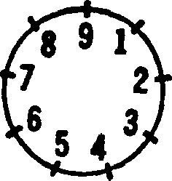 with the following description of this circle: "If we multiply 9x9 the result is shown in the number 8 on the left ride and the number 1 on the right side; in the same way 9x8 gives the product shown in number 7 on the left and in number 2 on the right; exactly in the same way with 9x6. Beginning with 9x5 the order becomes reversed, that is, the number representing the units takes the left side and the number representing the tens takes the right."

